PRN=230945920100

Name Sourabh Lowanshi

Module end exam =SDM

Date=06/01/2024

First we have to clone repository

Then we have to push to git hub

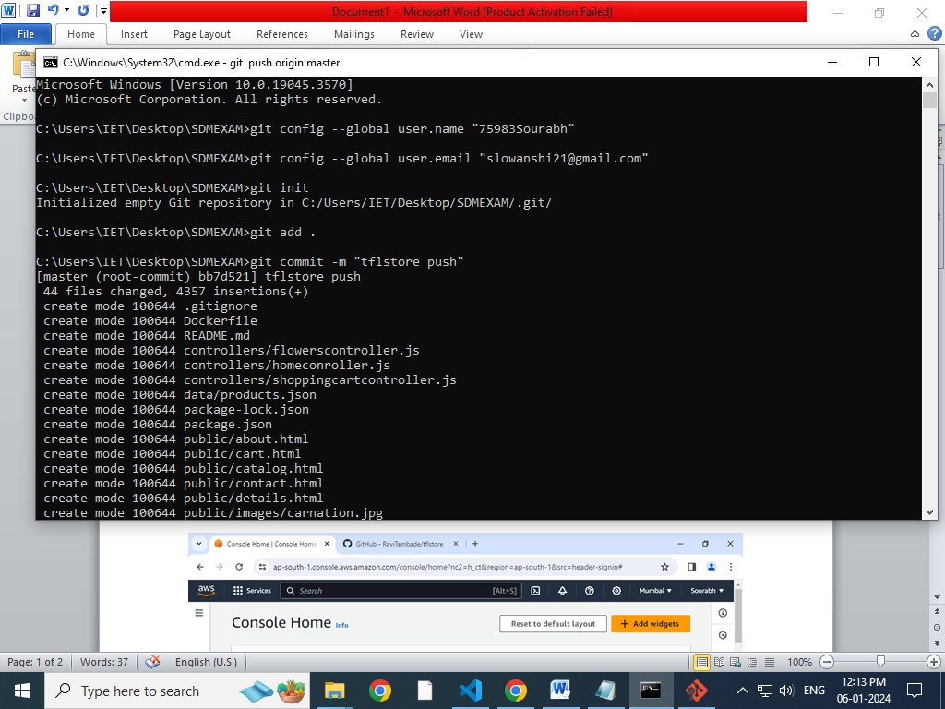

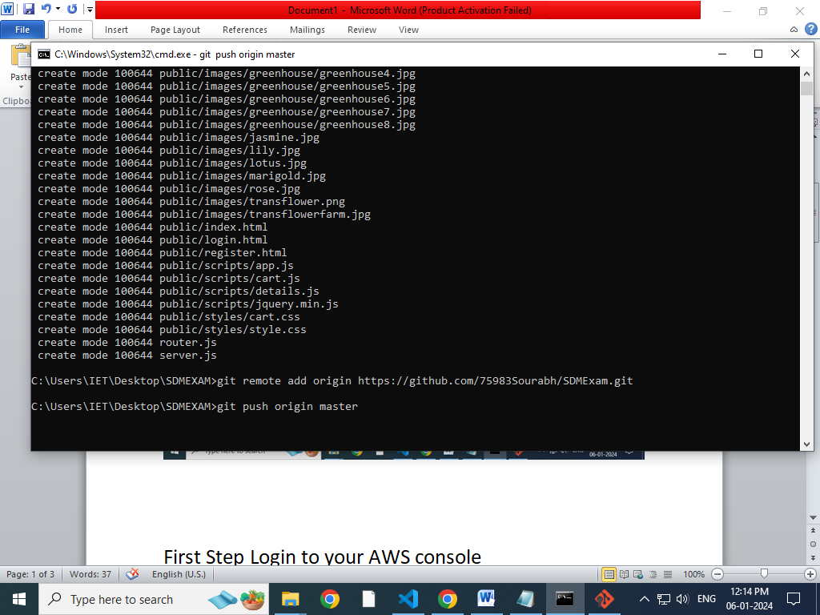then create a token

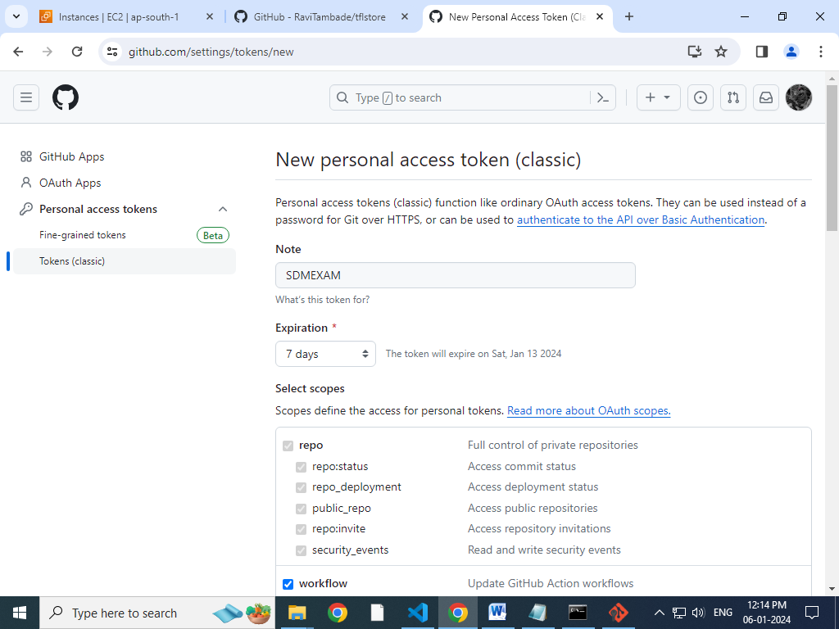

Heres the token

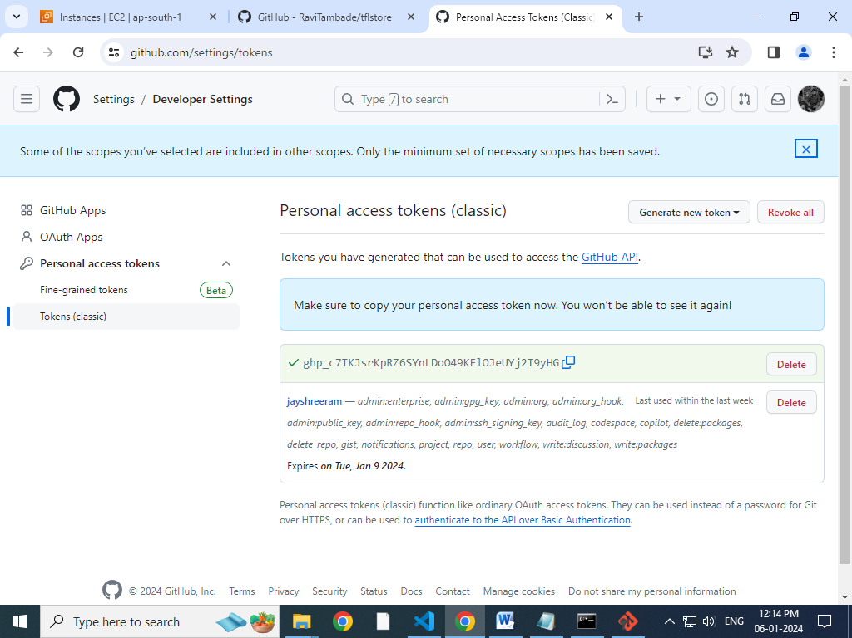

Pushed to git repository

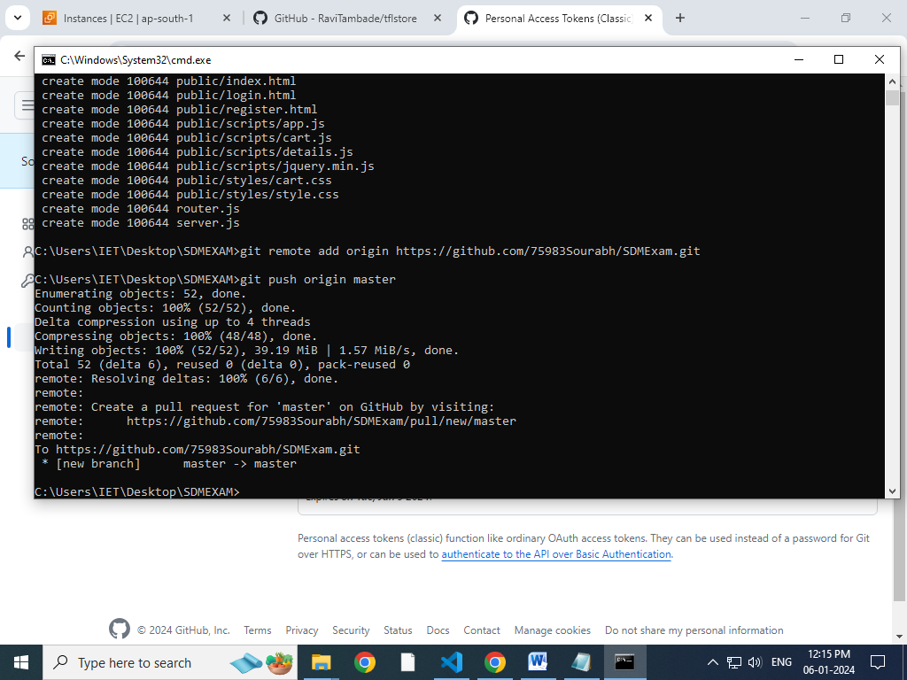

Check file is updated or not

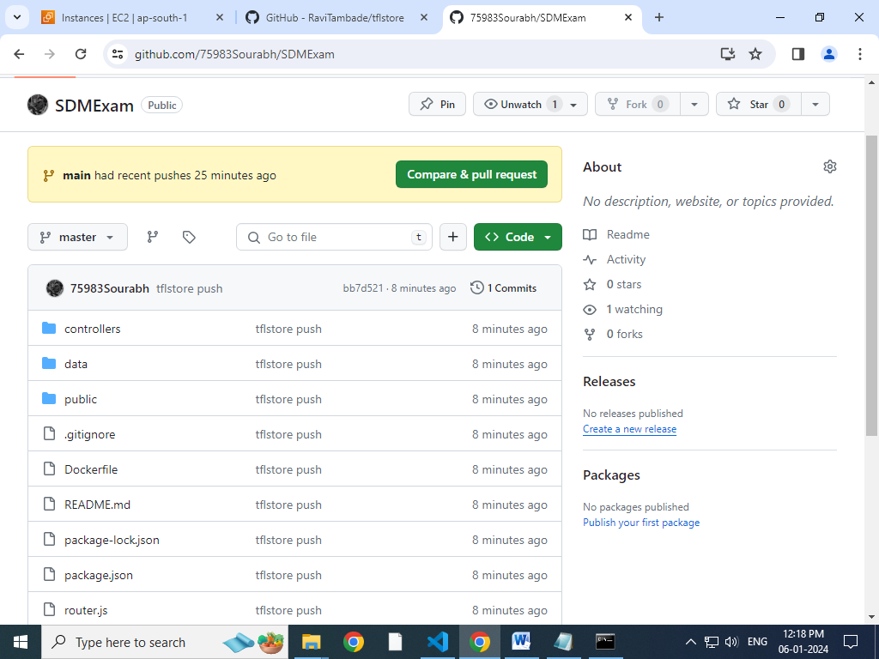

then Login to your AWS console

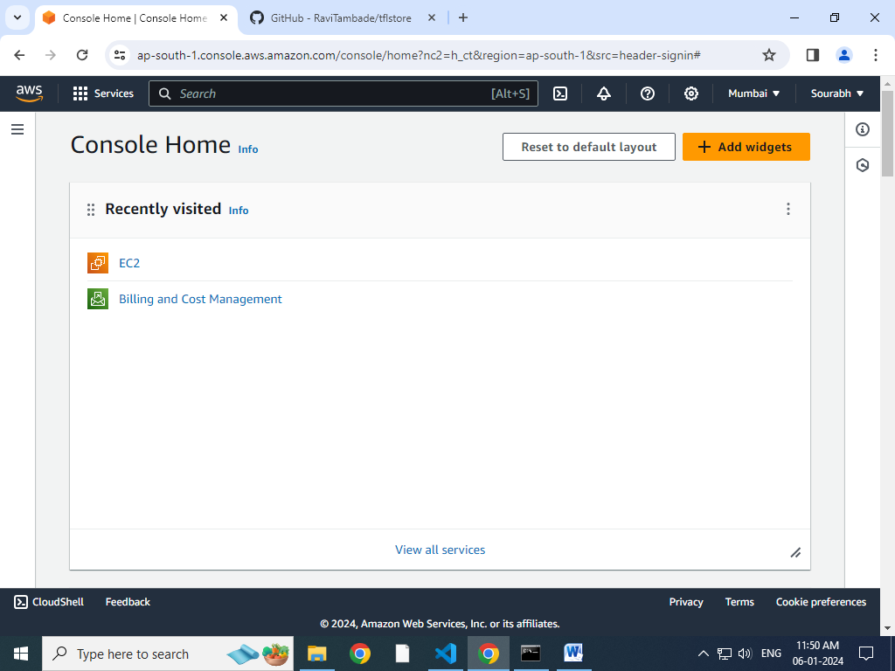

Then select EC2 instance

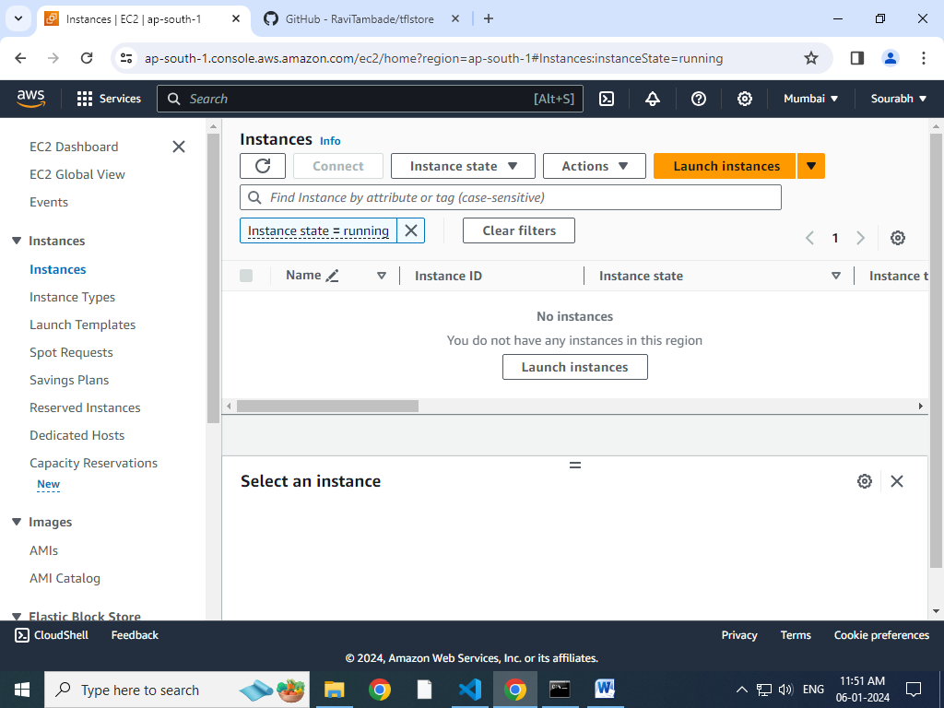

Then Launch instance

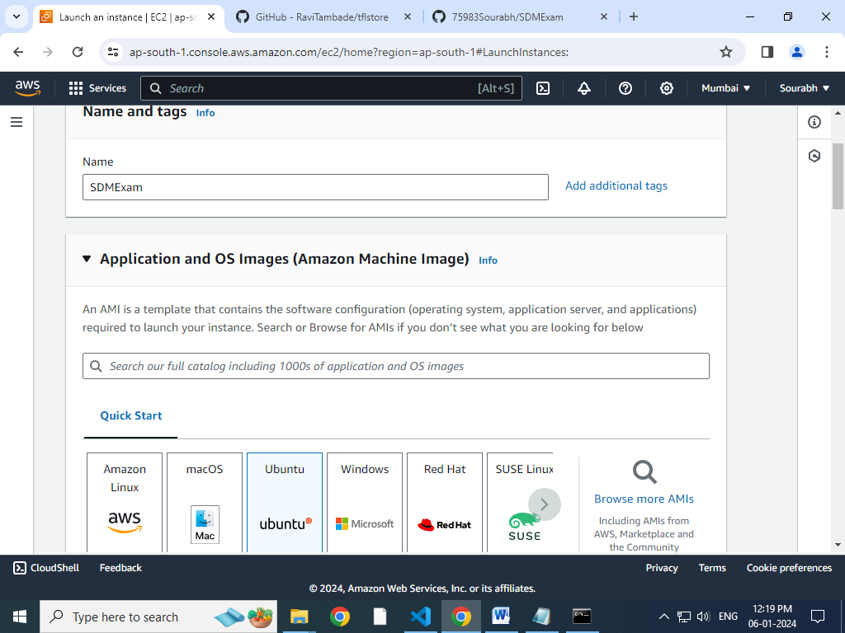

Give name to server and Select Ubuntu

Create a key

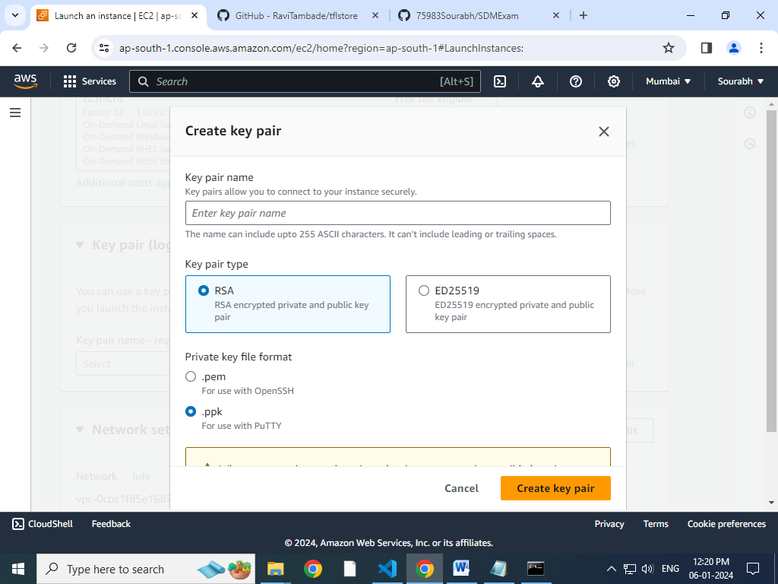

**Then Launch the instance**

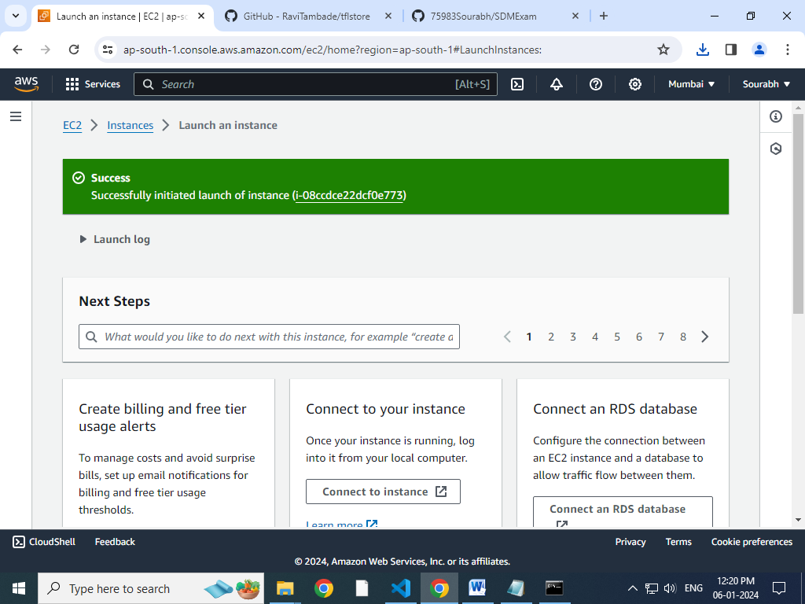

**Successfully Launched Then Go to that instance id and**

**Update security group**

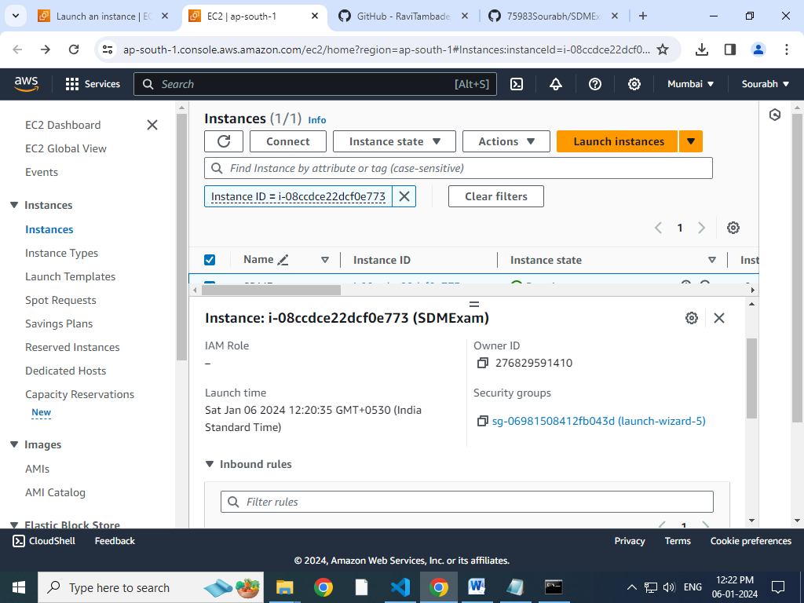

**Edit inbond Rules**

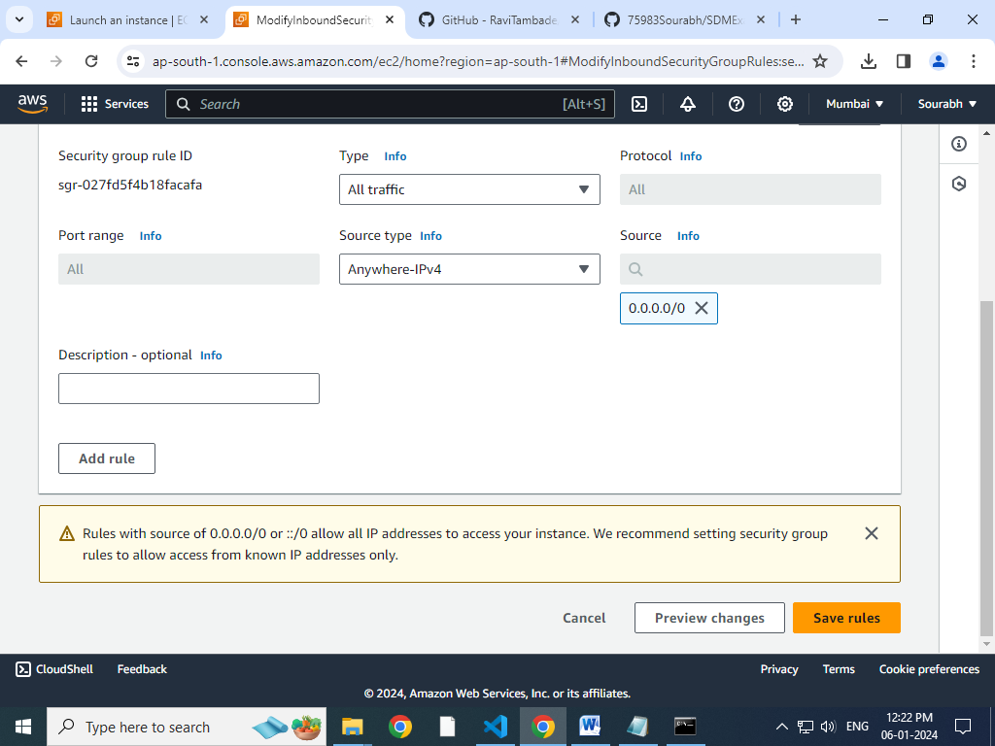

**The save rules**

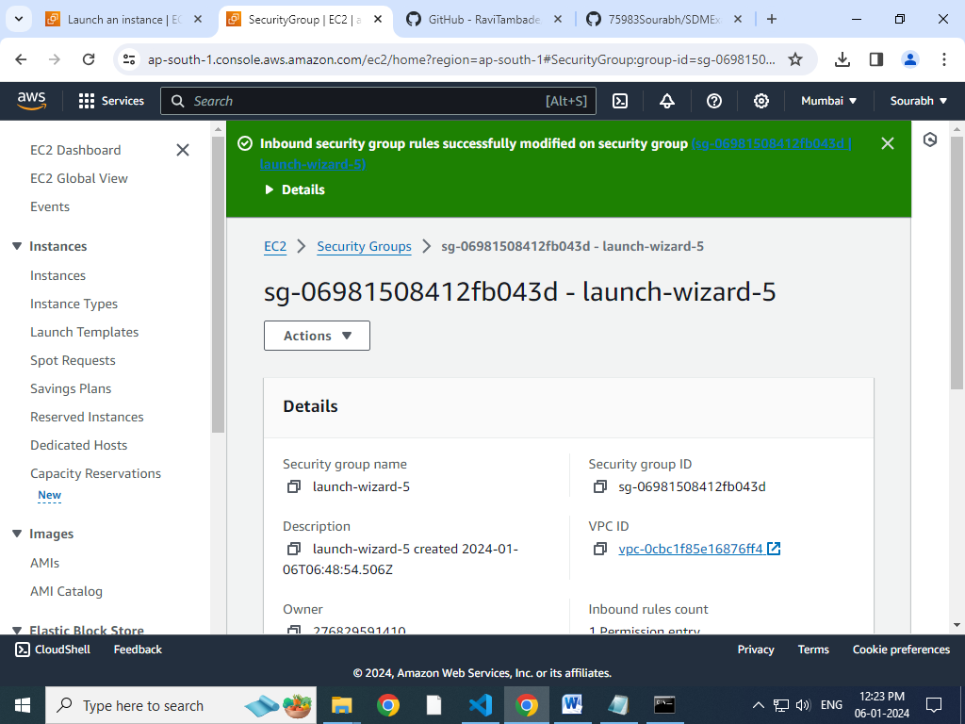

**Successfully Update security group**

**Now connect to instance**

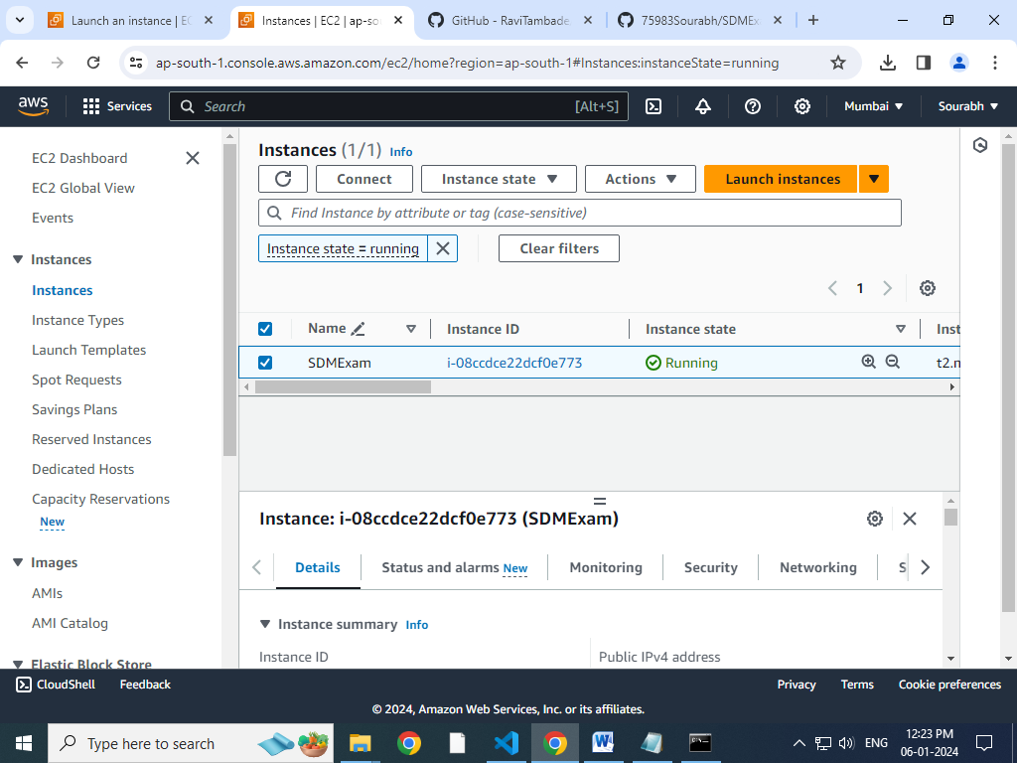

**Connect**

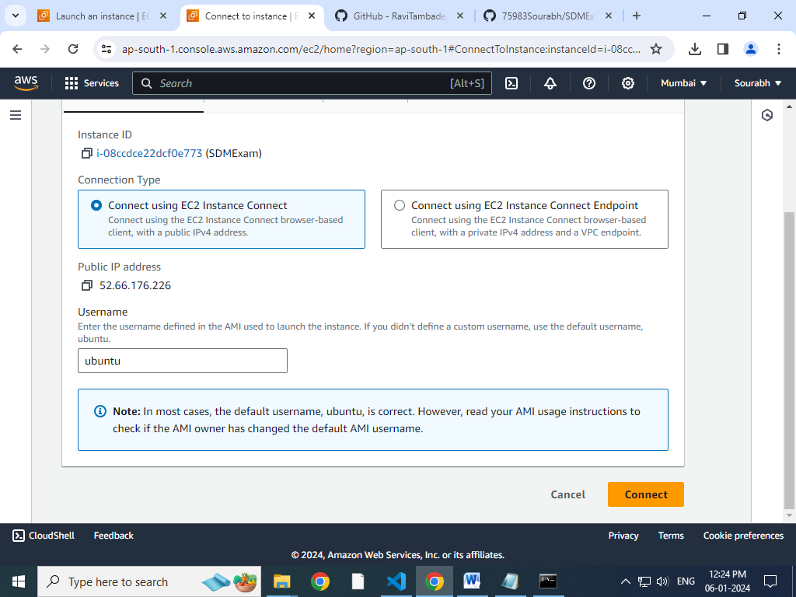

**Connected**

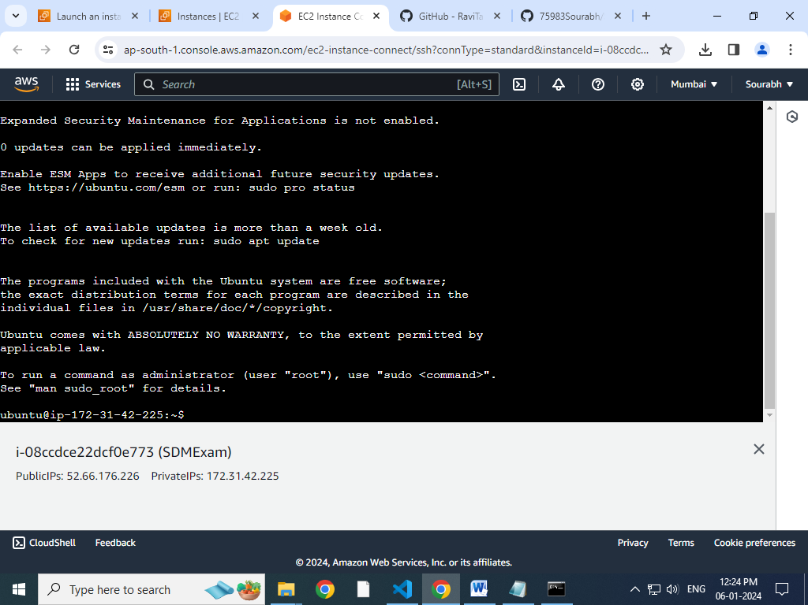

**Give command**

**Sudo apt update**

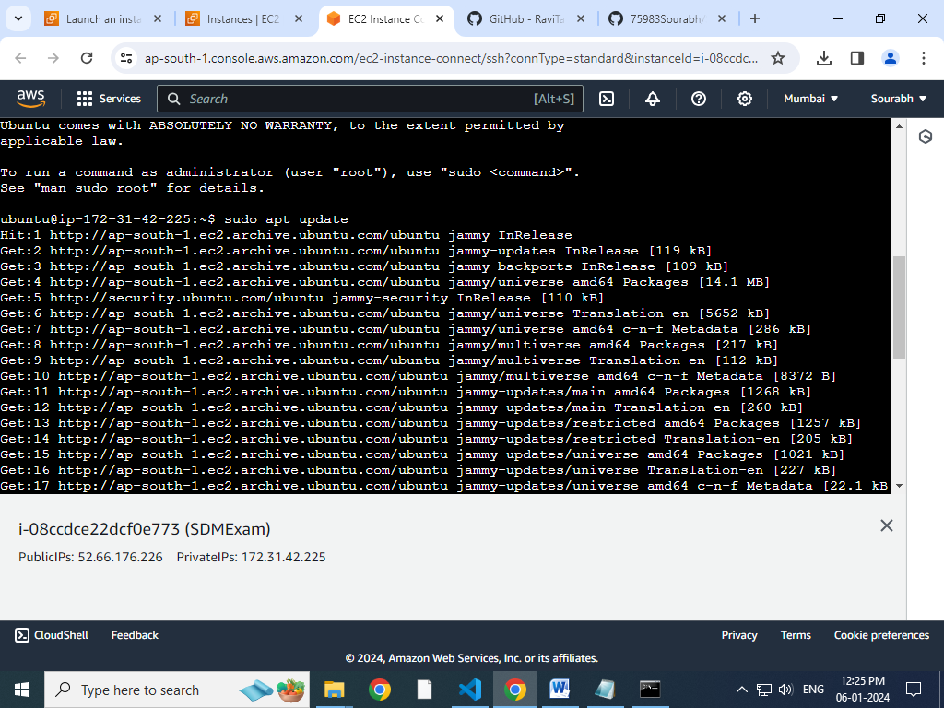

**Sudo apt install docker.io**

**Clone repository**

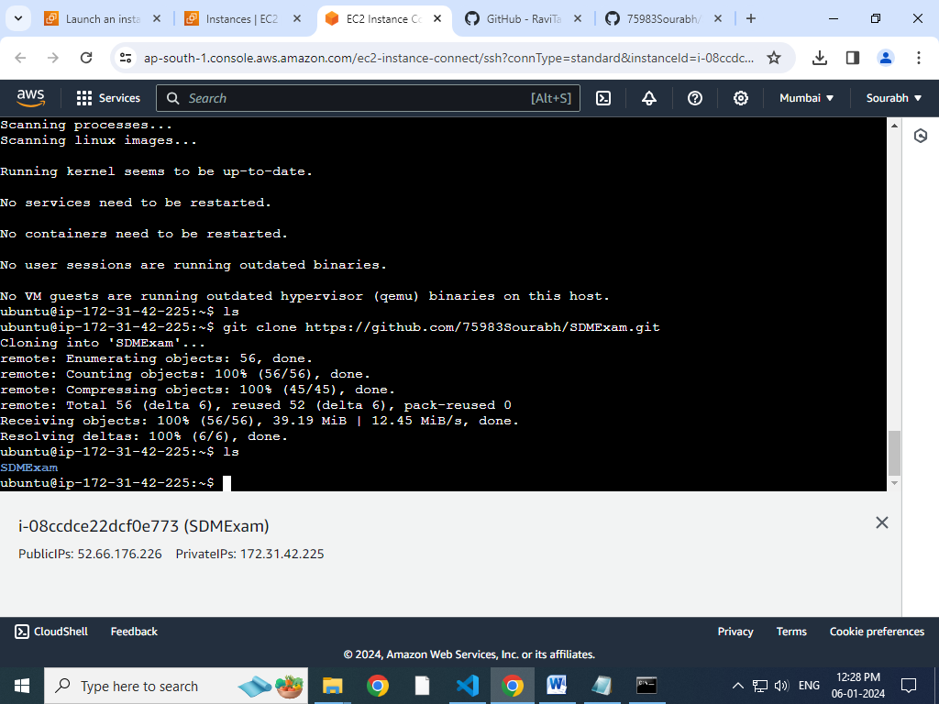

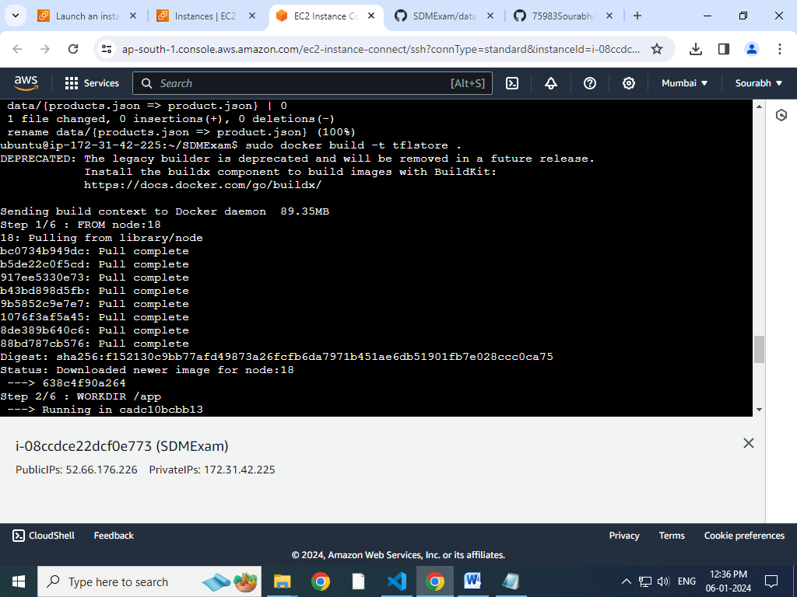

**Sudo docker build -t tflstore .**

**sudo docker run –d –p 8000:8000 tflstore**



**Finally done !!!**